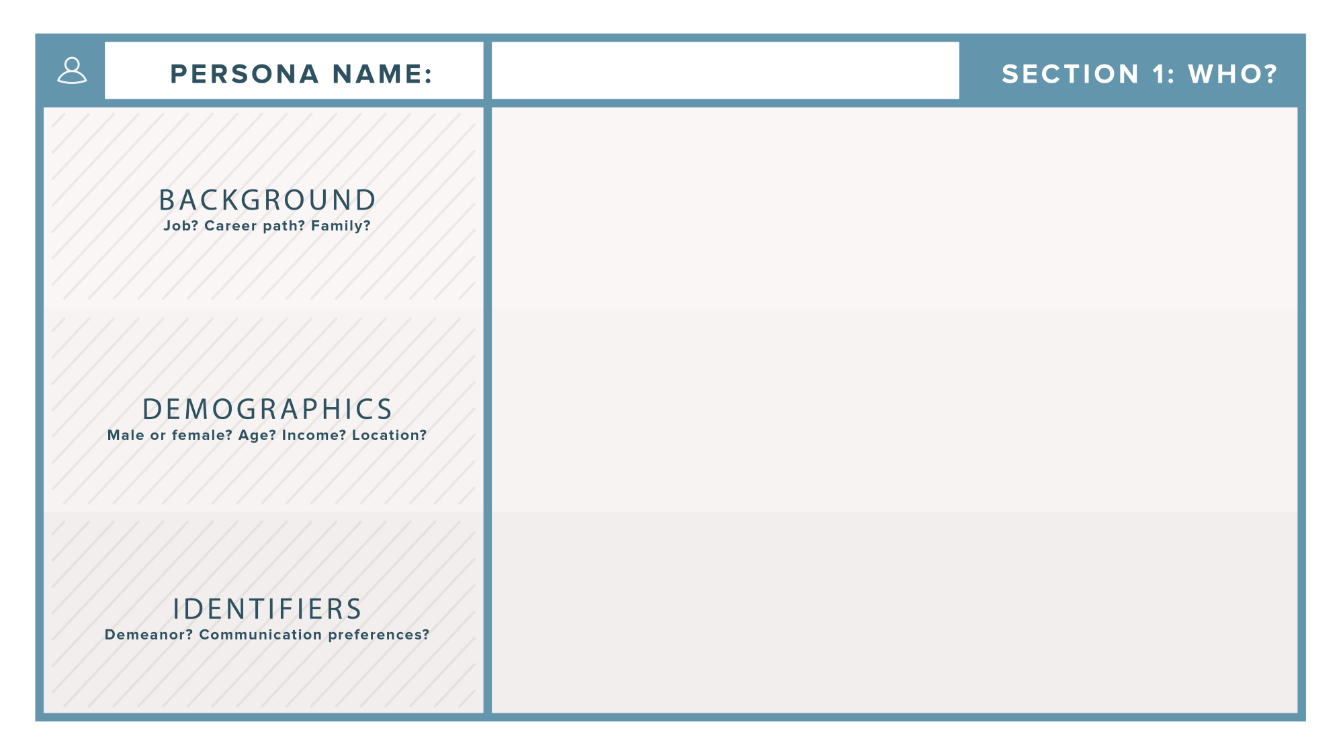

**MALAWI ROADS AUTHORITY**

* Was established in 2006 with the mandate to ensure that public roads are constructed, maintained and rehabilitated at all times
* Its headquarters located in Lilongwe.
* Emails or phone calls.

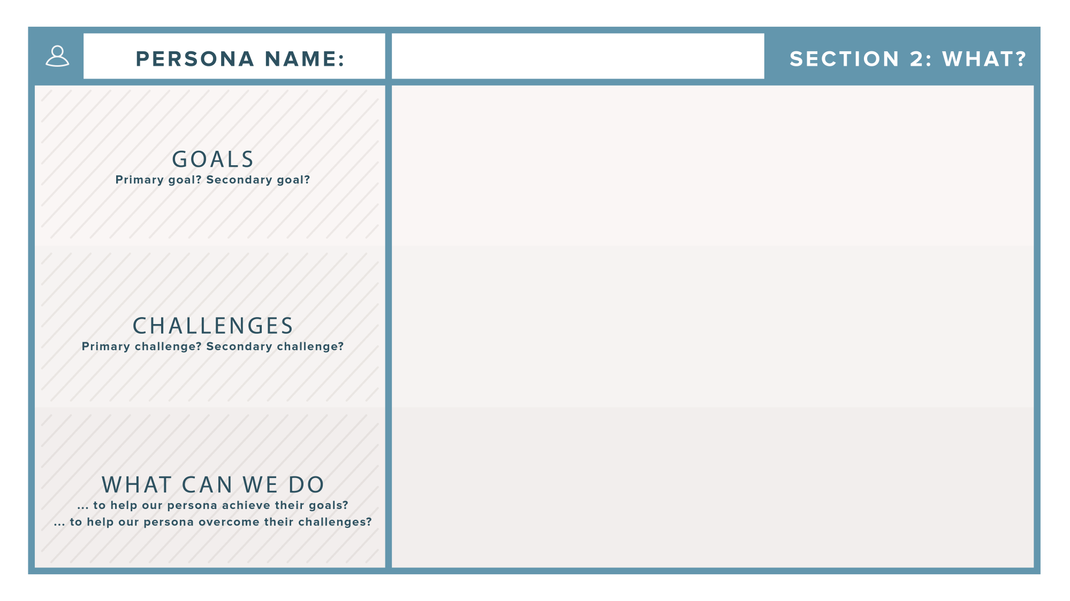

**MALAWI ROADS AUTHORITY**

* Ensure that public roads are constructed, maintained or rehabilitated at all times.
* Advise the Minister whenever appropriate on road issues.
* Difficult to know the health of bridges before severe damages
* Difficult to communicate or alert people in different areas on time on bridge statuses.
* Come up with a system which will notify the health of bridges, therefore allowing early maintenance.
* Civic educating people on the importance of the system so that they should not vandalize.

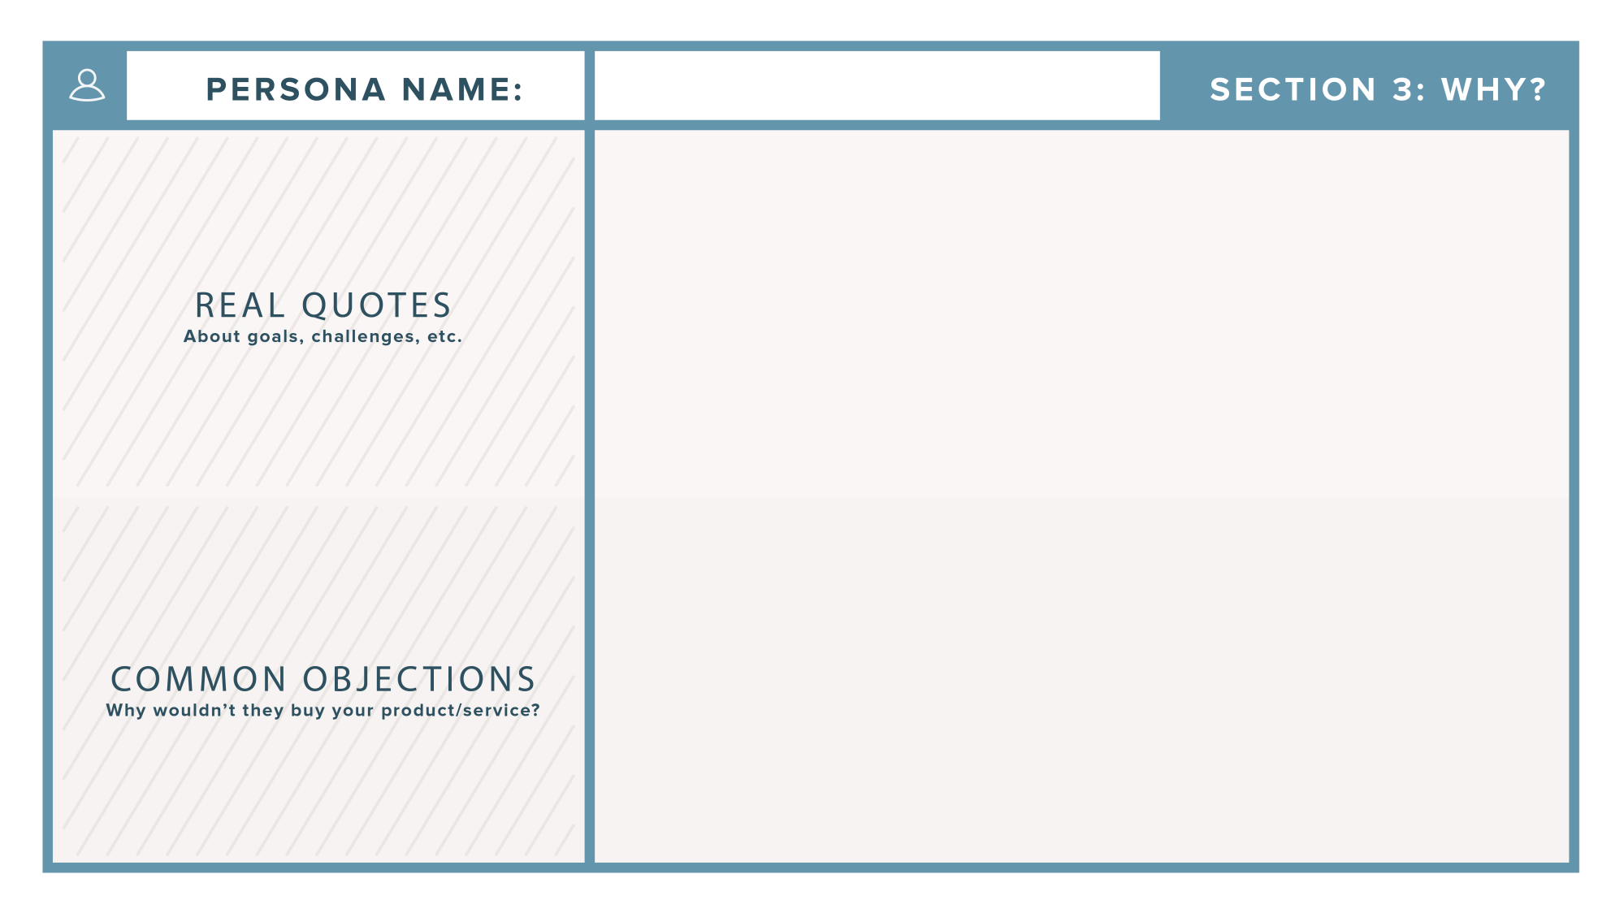

**MALAWI ROADS AUTHORITY**

* It would be difficult to implement the system on each and every bridge in the country.
* Be driven by the need to perform effectively, efficiently and economically in the construction and maintenance of roads in Malawi.
* Lack of supervision and condition of service of bridges and roads.

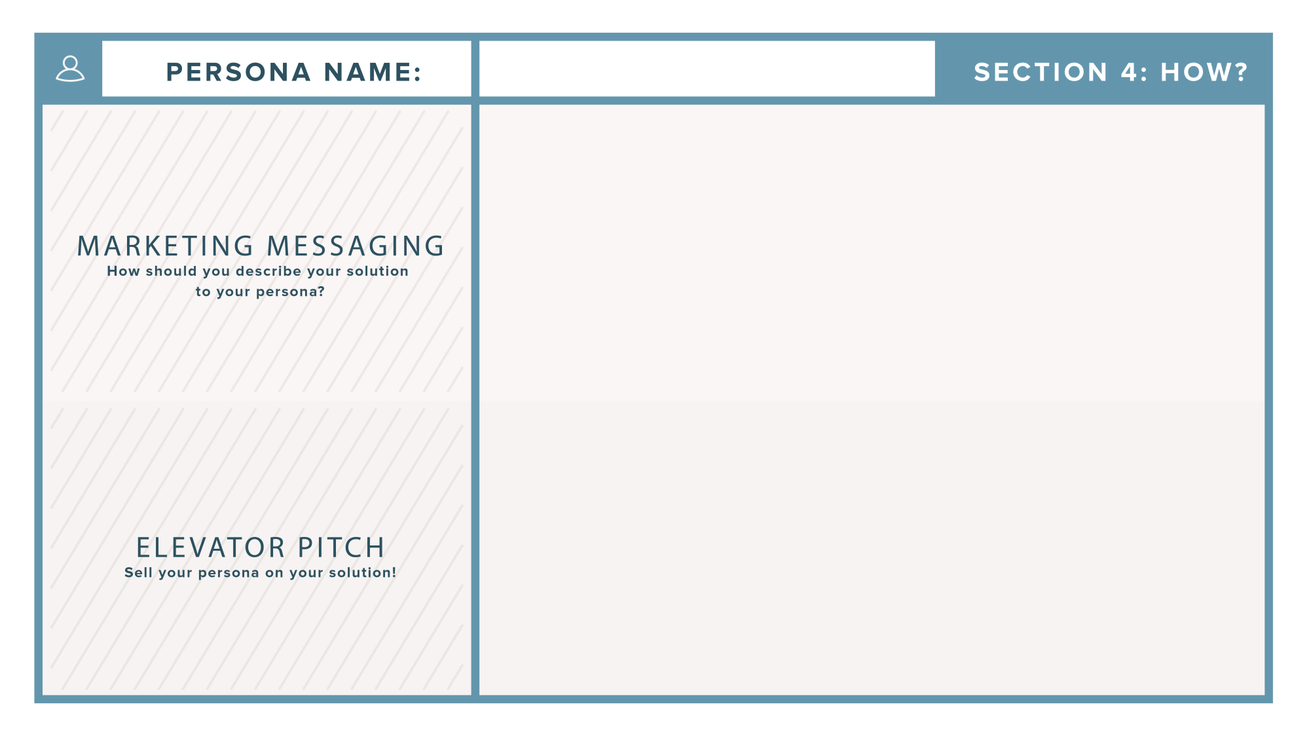

**MALAWI ROADS AUTHORITY**

* Development of IOT Based Bridge Health Monitoring System that will be capable of monitoring and alerting the target authority on the bridge conditions throughout the year.
* We give you a system that will monitor the health status of bridges at any time. Our system gives safety assurance and allows early maintenance therefore minimizing casualties and saving costs. This will help in the development of the country since there will be reliable good road networks, which will promote good trading.

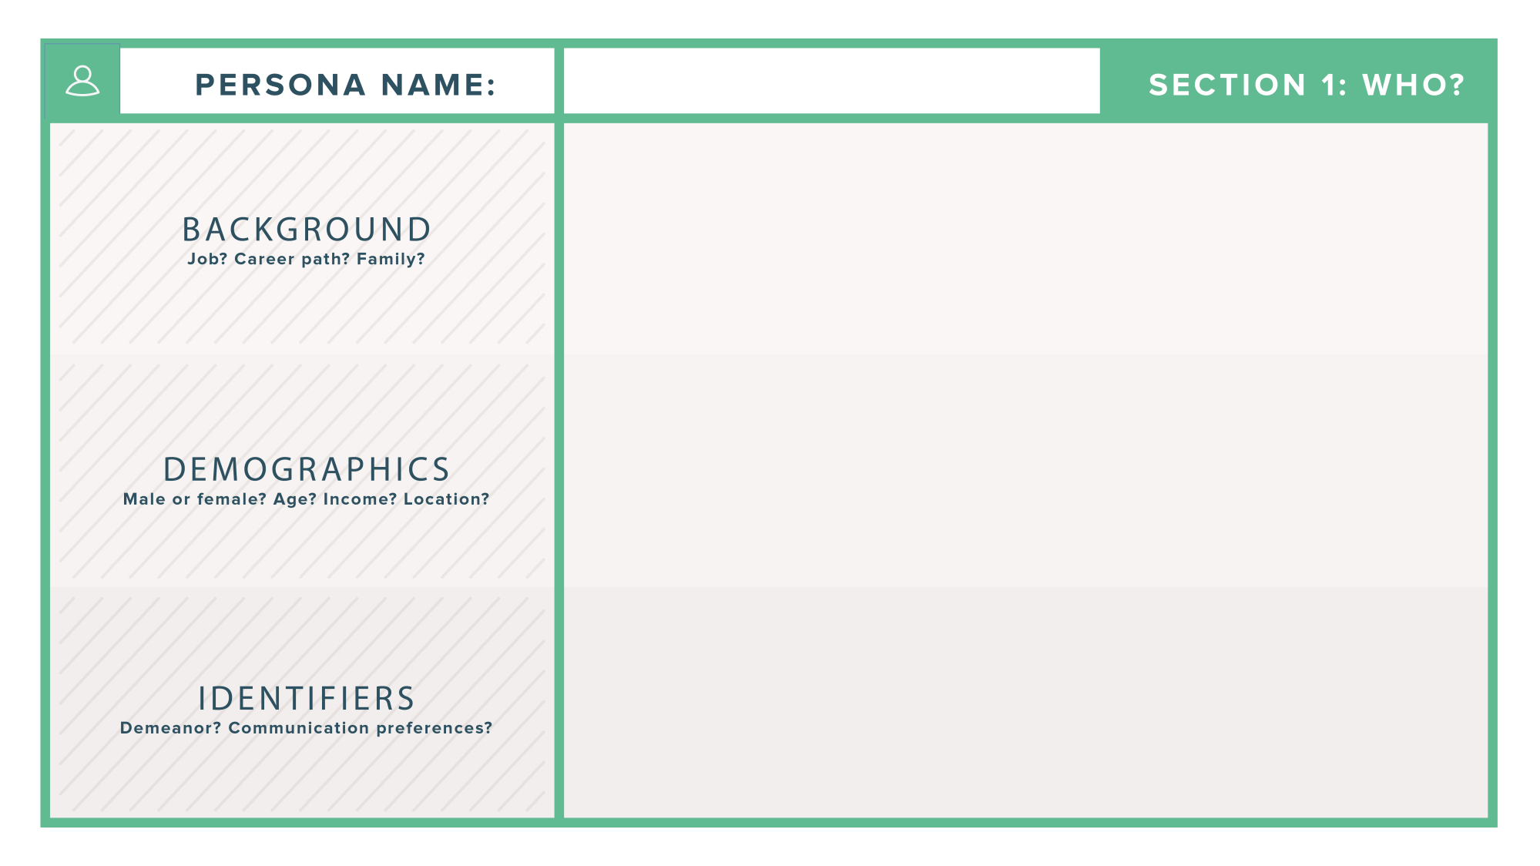

**PAUL KULEMEKA**

* CEO of Malawi Roads Authority.
* Worked 6 years at Malawi Roads Authority.
* Married with 4 children
* Male
* 46 years
* k800,000
* Lilongwe
* Friendly demeanor
* Emails or phone calls

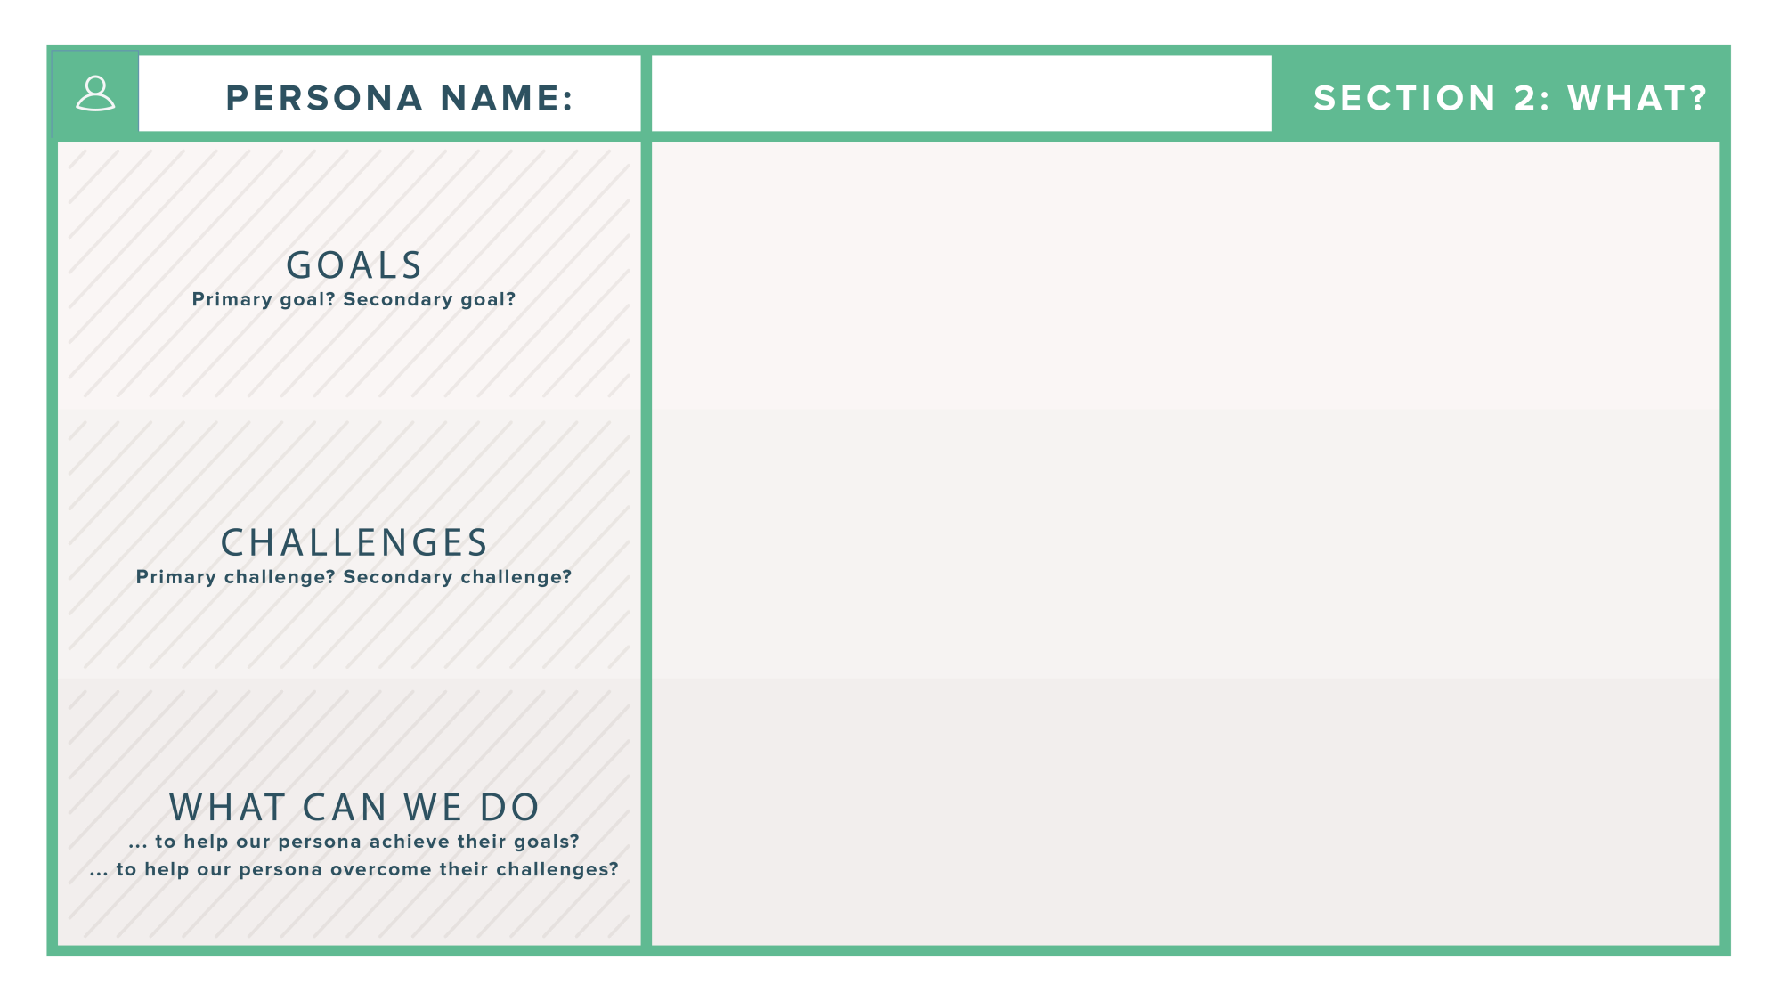

**PAUL KULEMEKA**

* To promote safe road networks.
* Save costs of maintenance of bridges and user assets
* Difficult to know the health of bridges before severe damages
* Difficult to communicate or alert people in different areas on time on bridge statuses.
* Come up with a system which will notify the health of bridges, therefore allowing early maintenance.
* It would be difficult to implement the system on each and every bridge in the country.

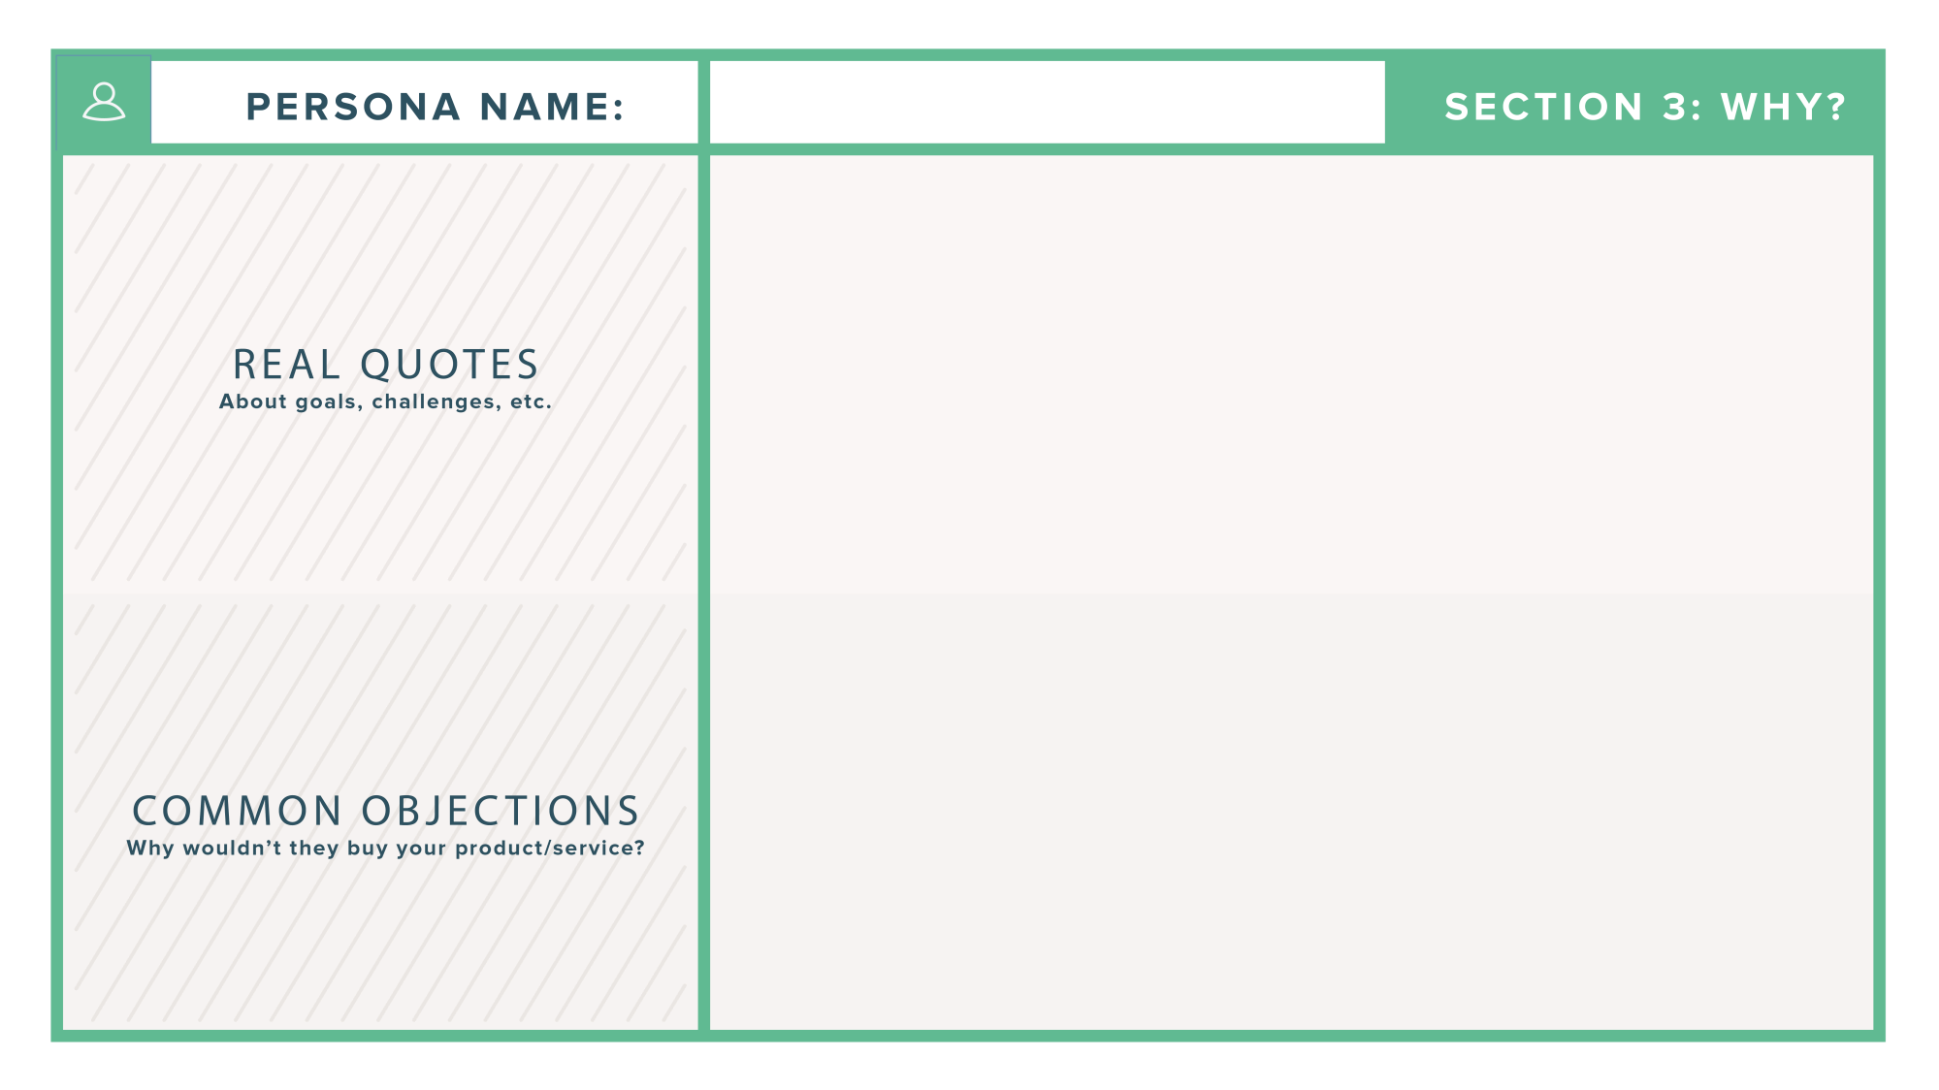

**PAUL KULEMEKA**

* It would be difficult to implement the system on each and every bridge in the country.
* “A developed Country is place where we have good and safe transportation system.”
* “In the age of information, ignorance is a choice.”

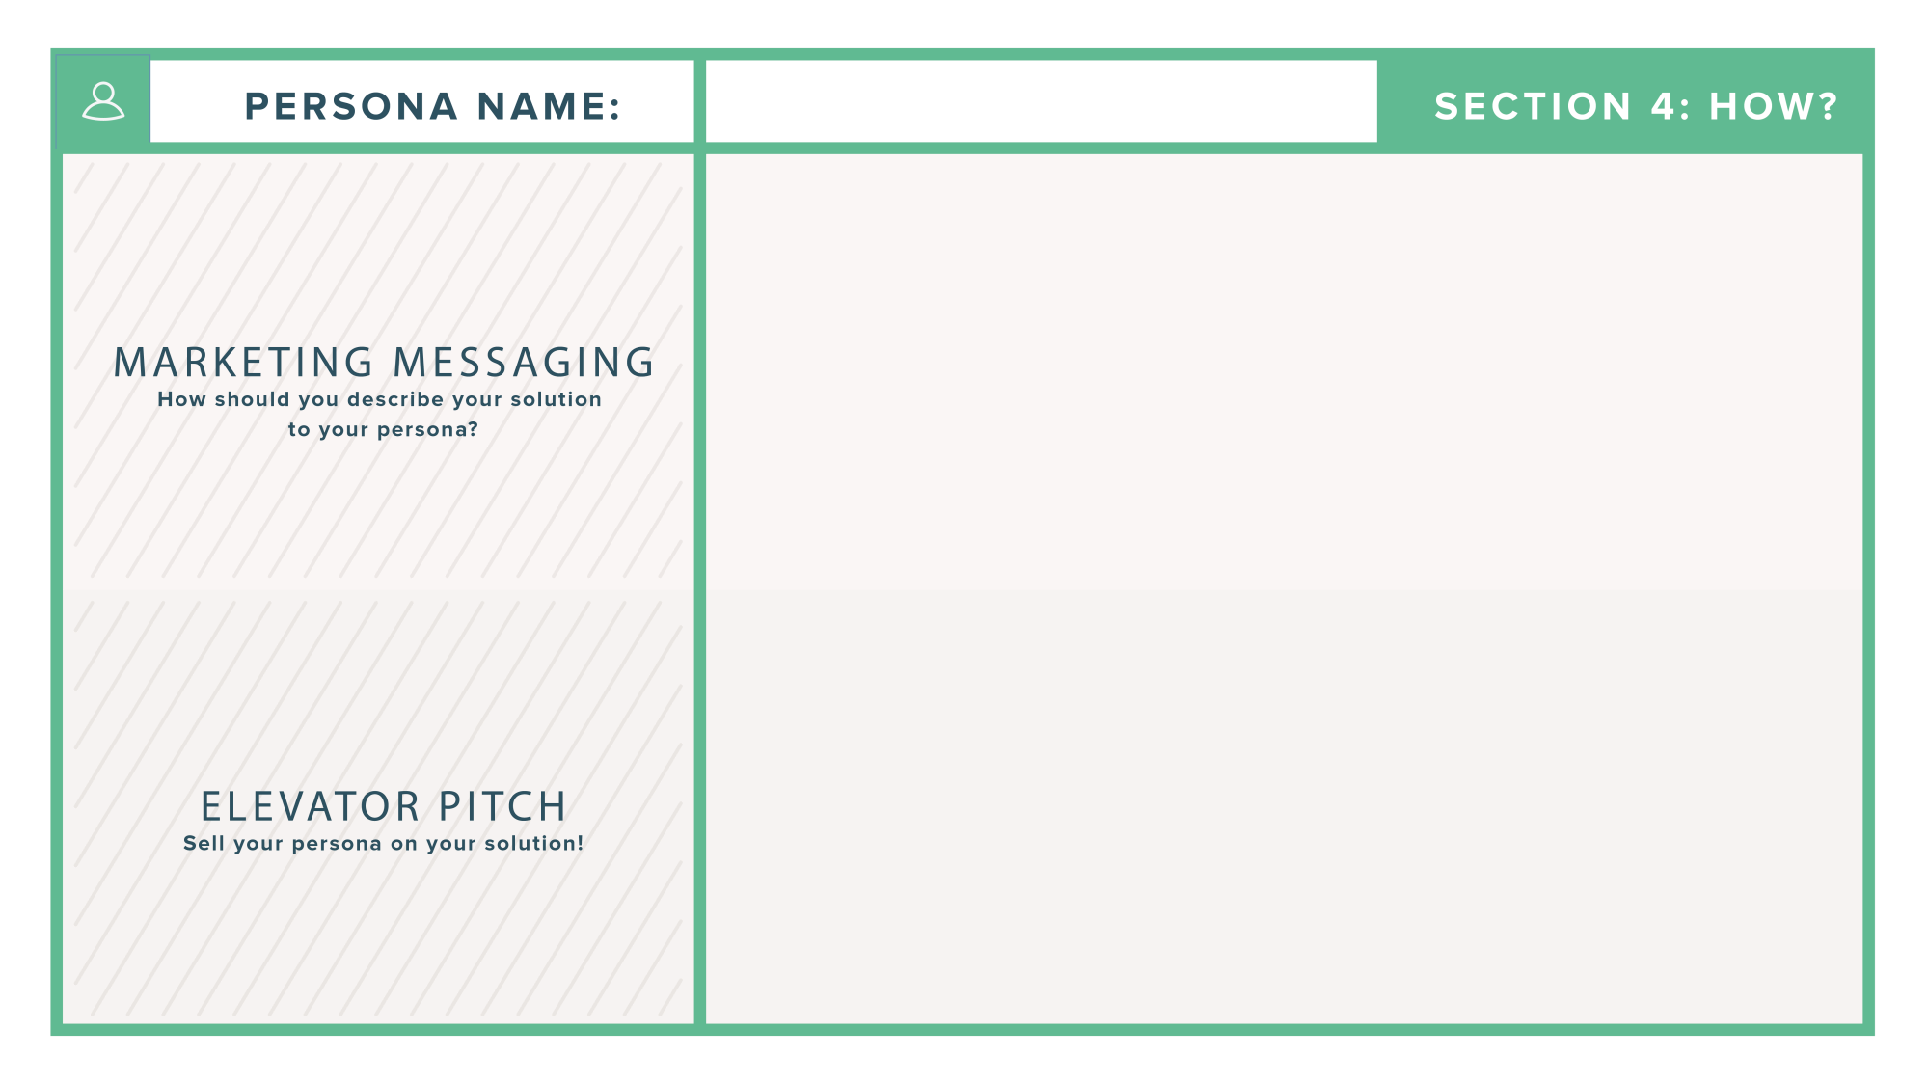

**PAUL KULEMEKA**

* Development of IOT Based Bridge Health Monitoring System that will be capable of monitoring and alerting the target authority on the bridge conditions throughout the year.
* We give you a system that will monitor the health status of bridges at any time. Our system gives safety assurance and allows early maintenance therefore minimizing casualties and saving costs. This will help in the development of the country since there will be reliable good road networks, which will promote good trading.